20 Tips for Using NBC Learn Higher Ed
Include these tips in newsletters, staff trainings, or other communications in order to enhance faculty’s understanding of NBC Learn. Feel free to pick and choose or send tips in any order based on the needs of your institution.

Getting Started
Tip 1  NBC Learn Video Tour | NBC Learn Higher Ed (highered.nbclearn.com) is a collection of more than 21,000 videos, documents, and images that can be incorporated into classroom lectures and online modules. New to NBC Learn? A guided video tour walks you through the site’s key features. Watch the whole video or skip ahead to specific features like Creating Playlists or Sharing Videos.  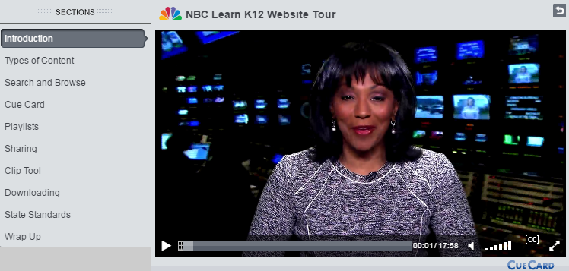
Tip 2  Using the NBC Learn Video Player | NBC Learn’s video player works like a baseball card: you can flip the player over to reveal more detailed information about the media on the front. Simply click on the backwards-facing arrow in the upper right corner to view a summary, hyperlinked keywords, and a citation generator for every NBC Learn video.  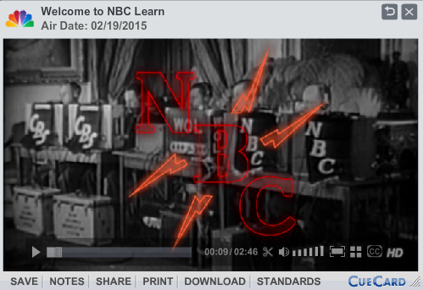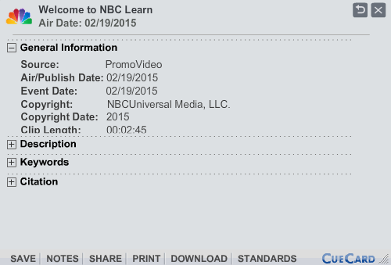
Tip 3  NBC Learn Transcript Feature | Every video on NBC Learn comes with a full text transcript, allowing students to cite specific evidence from the videos in discussions or written assignments. To access the transcript, open any video and click ‘Transcript’ on the right side of the player.  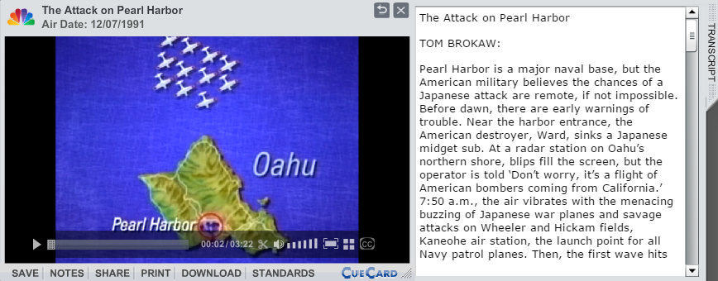
Tip 4  NBC Learn Offline Player | NBC Learn allows users to download an unlimited number of video playlists for offline use. Once you’ve downloaded the Offline App, it lives on your computer’s hard drive, and you can sync playlists any time you’re connected to the internet. When you’re not online, simply open the App to watch full videos—no need to search around or wait for videos to load!  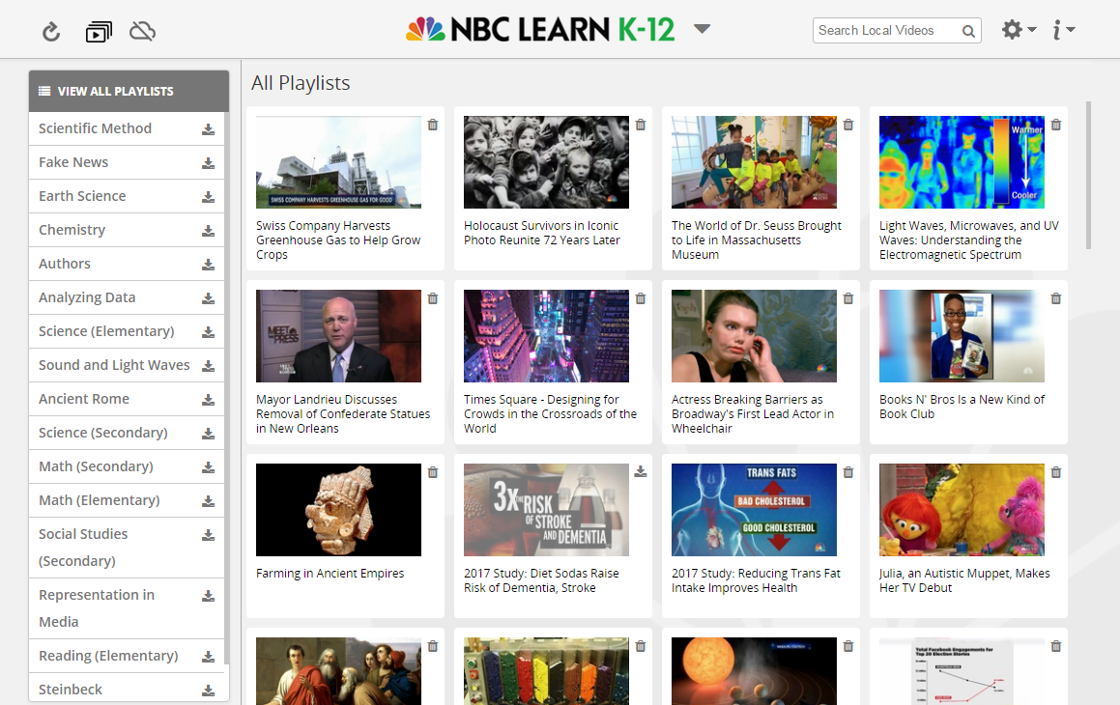
Tip 5  Citation Generator for NBC Learn Videos | Use NBC Learn’s video archive for research and generate Works Cited entries in no time. To create a citation:  - Flip over the video player by clicking the backwards facing arrow in the right corner.  - Click ‘Citation’ and choose from MLA, APA, and Chicago Style.  - Copy and Paste the citation to a Works Cited page.  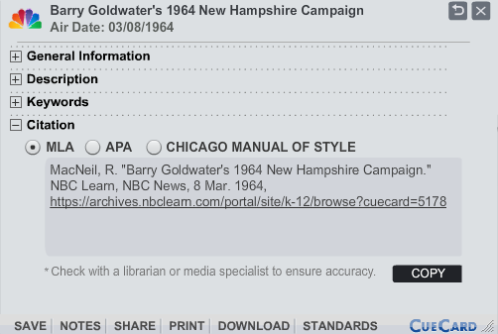
Tip 6  Creating Playlists | On NBC Learn, you can save groups of videos to a Playlist for easy access. To save videos:  - Click on the plus sign next to any video. The button will turn into a green checkmark once selected.  - Click on the ‘Tools’ dropdown menu in the right corner (underneath the search box). Select ‘Add to Playlist.’  - If you want to add the videos to an existing playlist, select the playlist from the window and click ‘Save.’  - If you want to create a new playlist, select ‘New,’ enter the playlist’s name and click ‘Save.’  - To access your playlists, click on ‘My Playlists’ from any page. To view playlists offline, download the NBC Learn Offline App.  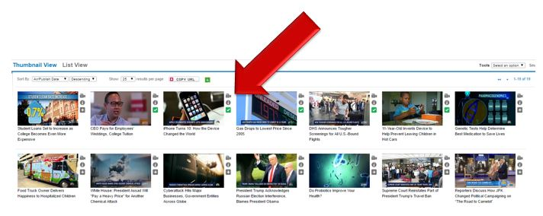
Tip 7  Embed videos into Canvas | NBC Learn features thousands of 2-6 minute videos, ideal for quickly recapping a historic event or introducing a new topic. To embed videos into an item on Canvas:  - Create a new item (Assignment, Quiz, etc.) in Canvas.  - In the text editor, click the NBC Learn button. This will open a pop-up window with the NBC Learn Homepage.  - In the pop-up window, open the video you want to embed and click ‘Embed.’ This will return you to Canvas.  - Add additional directions or questions for students. Click ‘Save’ when you’ve finished editing the item.  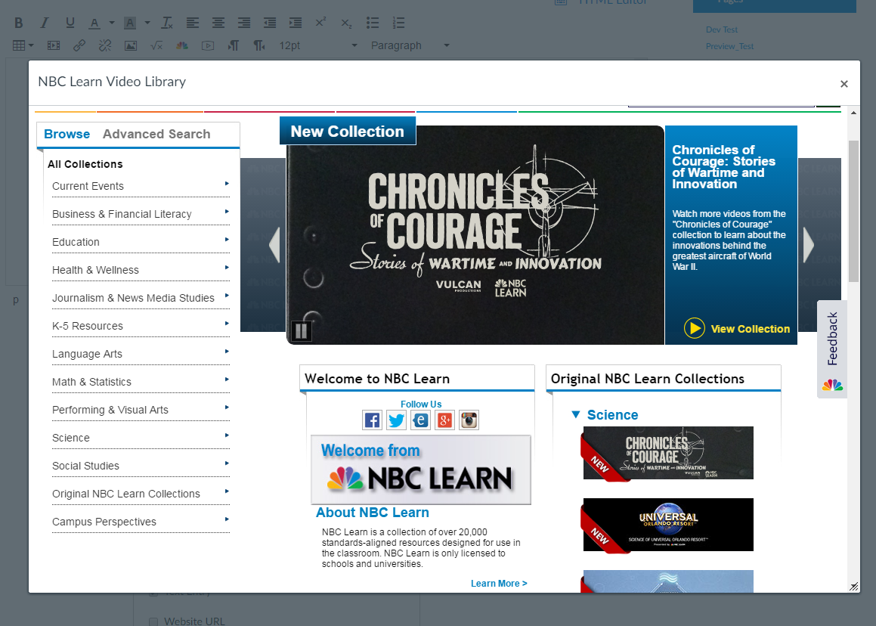
Tip 8  Create Discussions with NBC Learn Videos | Increase student engagement by asking them to share and analyze NBC Learn videos in Canvas discussion forums. Use forums to discuss:  - Current Events related to course topics  - Case Studies  - Videos chosen by students to share with the class  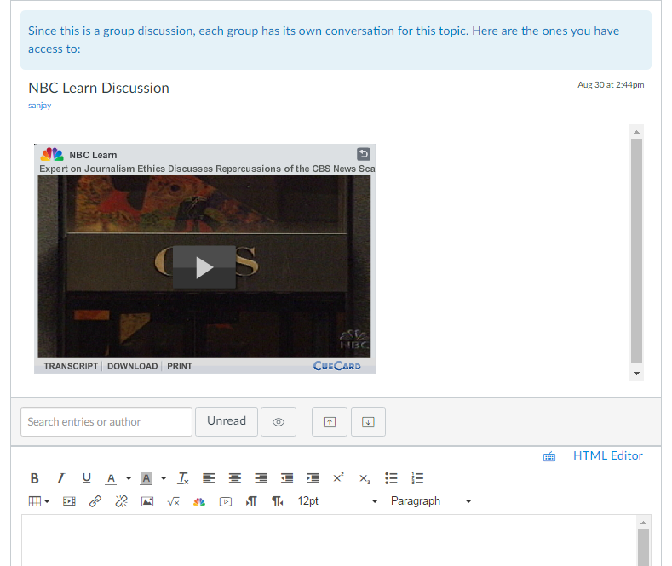

Discovering Videos
Tip 9  Browse NBC Learn’s 40+ Collections | NBC Learn Higher Ed has more than 40 Collections, including Business Administration, Communications, and Health and Wellness. Click on the menu on the left side of the page to start exploring. Each collection contains several sub-topics, allowing you to further narrow the results. To return to a broader topic, click on the name of the collection at the top of the menu or click ‘Back.’  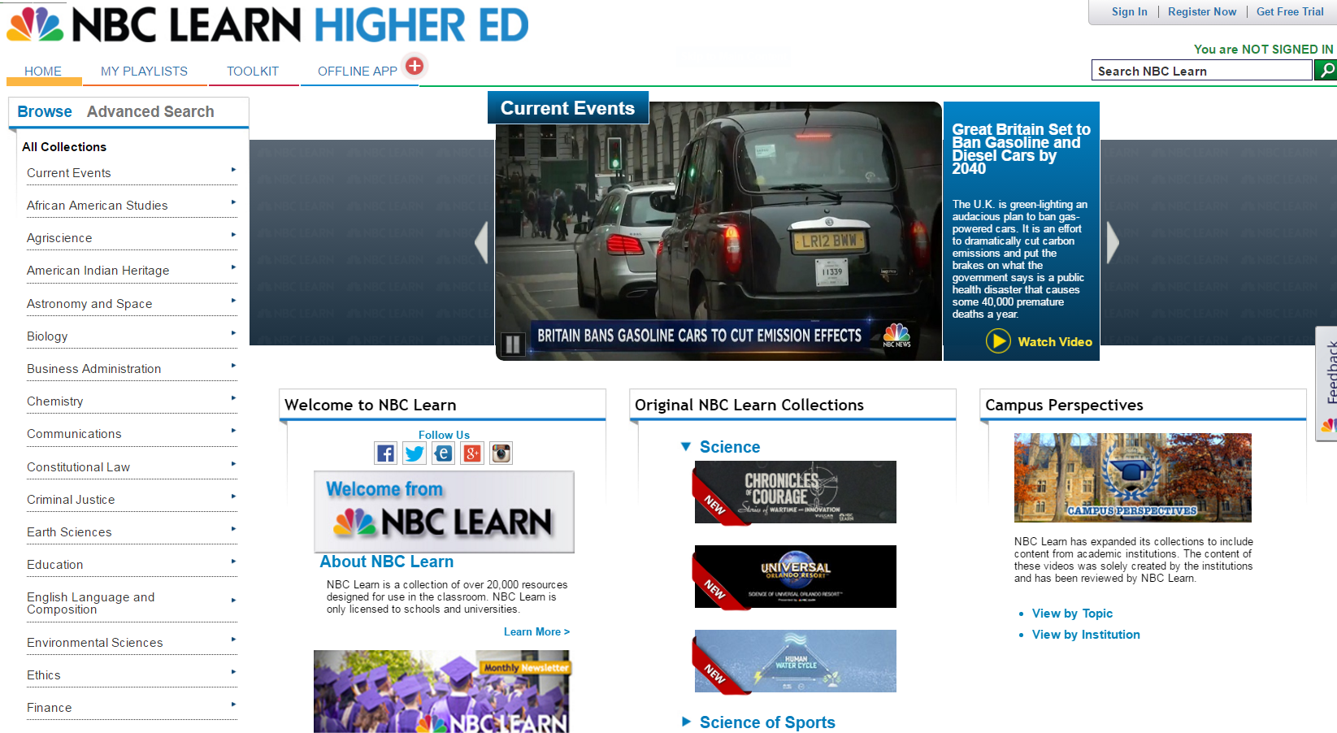
Tip 10  NBC Learn Advanced Search | With over 21,000 resources, NBC Learn has videos to increase relevancy and rigor for every course. After performing a keyword search on NBC Learn, use our Advanced Search to filter results by:  - Event Date or Air/Publish Date  - Collection (e.g. Biology, Marketing)  - Source (e.g. Archival Film, NBC Nightly News)  - Type (e.g. Document, Video)  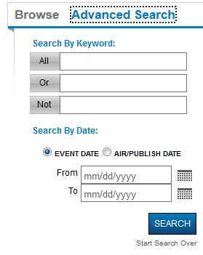
Tip 11  Use Keywords to Find Related Videos on NBC Learn | Every video on NBC Learn comes with a list of Keywords on the back of the video player (click the backwards-facing arrow in the right corner to reverse the video player). Use these to generate key terms lists for students or discover related videos by clicking on the hyperlinked keywords.  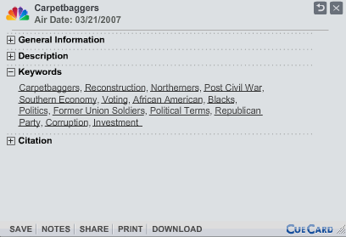
Tip 12  Curriculum Alignments | With over 21,000 resources across 40 disciplines, NBC Learn is a powerful tool that can increase engagement and relevancy in your course—no matter the subject. For faculty at your school, we offer complimentary curriculum alignments so you can determine the resources that best fit your course. Email syllabi or other materials to account.management@nbcuni.com to take advantage of this free service.

Featured Content
Tip 13  Business Case Studies from NBC Learn | Ask students to apply business concepts to analyze case studies from NBC Learn’s Business Administration Collection. Topics include:  - Current Events in Business such as United Airlines’ new plan to cut down on oversold flights  - Career Profiles on Steve Jobs, Marissa Mayer, and more!  - Innovation in Business, including How Grocery Stores Are Using Algorithms to Stock Their Shelves  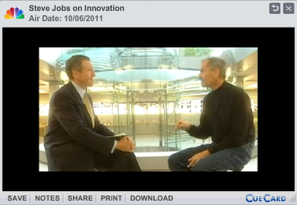
Tip 14  Health Innovation Videos on NBC Learn | NBC Learn can help students pursuing careers in healthcare stay up-to-date on the latest innovations in their field. The Health & Wellness Collection features hundreds of videos, including:  - The findings of recent scientific studies—2017 Research Shows Link Between Poor Sleep and Increased Alzheimer’s Risk  - Developments in medical technology—Can Virtual Reality Sessions Treat Chronic Pain?  - Changing practices in healthcare—Telemedicine, Billed as the Future of Medicine, Is Here Now  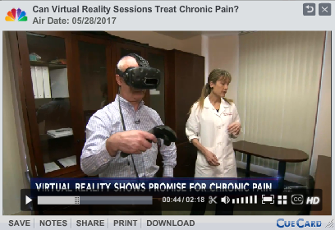
Tip 15  Historic News Broadcasts from NBC Learn | NBC Learn features broadcast news archives and Universal Newsreel footage dating back to the 1930s. Share these with students to illustrate shifts in media coverage and public perception of events from history.  - A Look at Segregated Busing (Civil Rights Moment, 1955)  - Viet Cong Attack on US Bases at Pleiku (Vietnam War, 1965)  - Supreme Court Hears Case of United States v. Nixon (Watergate, 1974)  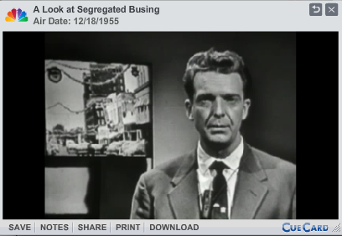
Tip 16  History Mini-Docs from NBC Learn | 2-6 minute mini-documentaries from NBC Learn can help students quickly review important historical topics, from Women in Medieval Times to Thurgood Marshall and Brown v. Board of Education. Use these resources to get students up to speed before delving into more complex analysis or assigned them as review before exams. Check out NBC Learn Original Social Studies Videos or US History Collection for more videos.  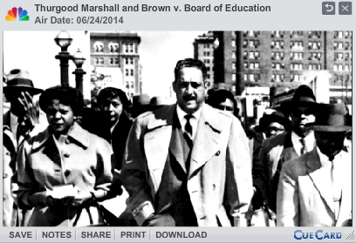
Tip 17  Inspiring America and Making a Difference on NBC Learn | NBC Learn features stories from “Inspiring America” and “Making a Difference,” two series from the Nightly News that profile individuals and organizations having a positive impact on their communities. Use the videos to:  - Discuss social entrepreneurship case studies  - Inspire student leadership  - Highlight underreported issues facing specific communities  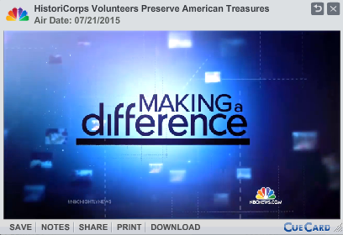
Tip 18  Primary Source Videos from NBC Learn | NBC Learn offers a wide variety of primary sources for teaching and research. Featuring full text transcripts in addition to video footage, NBC Learn offers users the ability to relive key moments from American history. Collections include:  - Speeches from the Civil Rights Movement  - Political Ads dating back to 1952  - Presidential speeches  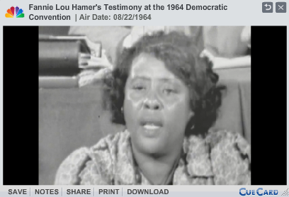
Tip 19  Science Videos on NBC Learn | Video footage and explanatory graphics in NBC Learn science videos can help illustrate complex concepts. Popular series include:  - Changing Planet—From melting permafrost to the spread of infectious disease, this series outlines the impact of climate change on Earth.  - Mysteries of the Brain—Seven videos introduce students to the structure and functions of the brain.  - When Nature Strikes—This series features striking footage of natural disasters and detailed explanations from experts who study them.  - NBC Learn Original STEM Videos—This collection features 2-6 minute explainer videos ideal for reviewing basic concepts.  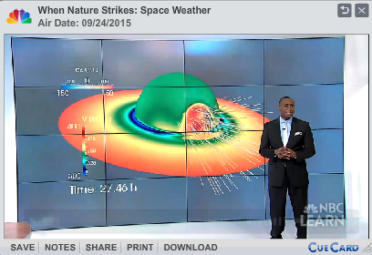
Tip 20  Writers Speak Collection from NBC Learn | NBC Learn’s Writers Speak collection features authors from all genres discussing influences on their work. Videos can be used to provide context on an author’s work or models for students’ own writing process. Videos include:  - Ralph Ellison on “Invisible Man”  - Junot Diaz on His Newest Novel and Being Dominican  - Maxine Hong Kingston on “Woman Warrior”  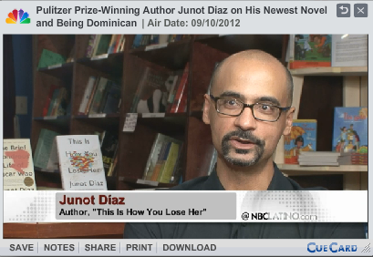

Looking for more?
Visit our online Toolkit for more teaching resources and how-to’s.
Contact: Melissa Cail
Education Specialist
melissa.cail@nbcuni.com
@MelissaNBCLearn NBC Learn

