Office of Teaching and Learning Conference Room Policy
Policy Statement
The following policy and procedures have been developed to ensure the proper use and preservation of the Office of Teaching & Learning (OTL) Conference Room. All requests, scheduling, and arrangements are handled by the OTL Administrative Assistant. All conference room reservations are subject to cancellation based on priority needs.

Availability
The OTL Conference Room is available to OTL staff for department-related meetings and events, and university faculty and staff for OTL-affiliated meetings and events. Room reservation requests for meetings and/or events not affiliated with the OTL will be subject to approval. The OTL Conference Room is not available for use as a classroom or for non-university-related activities.

University Departments: The OTL Conference Room is available for meetings but not for ongoing classes, workshops or seminars. The OTL Conference Room is available Monday through Friday, 8:30 a.m. to 4:30 p.m. ONLY.

OTL Staff: The OTL Conference Room is available for OTL-related meetings and events. OTL-related meetings and events are given priority use of the room.

Reservations
University Departments: Reservations by University groups are accepted at least 48 hours but no more than 30 days in advance of the requested meeting, and must be received via the Qualtrics Survey https://udenver.qualtrics.com/jfe/form/SV_3pZi1XYjm8KBYOh. Upon completion of the request survey you will be emailed with a notice of room availability. Your reservation is not complete until you have submitted the OTL Room Reservation Request form and have received written confirmation from OTL.

OTL: It is suggested that OTL-related meetings and events be booked as far in advance as possible (to guarantee that you are not competing with another OTL-related event, book at least 30 days in advance). All conference room reservations must be recorded in the Outlook OTL Conference Room calendar. Holds can be placed for tentative meetings, but are subject to review. Reservations should be made at least 48 hours prior to use.

Access to the OTL Conference Room
The OTL Conference Room is located on the 3rd floor of Anderson Academic Commons and is locked at all times. To have the room unlocked please visit the Office of Teaching and Learning (Anderson Academic Commons, room 350) and request the door be unlocked by the Administrative Assistant.

Room Setup
University Departments: The OTL is not responsible for room set-ups or take downs. Those interested in rearranging the OTL Conference Room should provide additional time in their OTL Conference Room Reservation Request Form for room set-up and take down.

The OTL Conference Room has a standard arrangement. The room can be rearranged as needed, but must be returned to the original setup at the conclusion of the meeting. Misuse of the space, damage to the space, or failure to rearrange the room back to its standard set-up may result in suspension or cessation of room usage privileges.

OTL: The room can be configured in any way you desire, but please rearrange the room back to its standard set-up upon completion of events or meetings. OTL staff who would like assistance with room set-up should provide the Administrative Assistant with detailed instructions for the preferred arrangement prior to the event.

The OTL Conference Room’s standard arrangement is two small squares and a large rectangle. The squares are each composed of two light brown tables and the rectangle is made up of two long tables placed side by side with the smaller dark brown tables at the ends. Each small square is surrounded by four chairs and the large rectangle is surrounded by 10 chairs.

Please reference the images below:

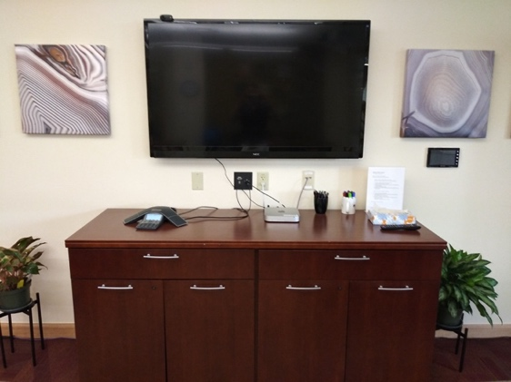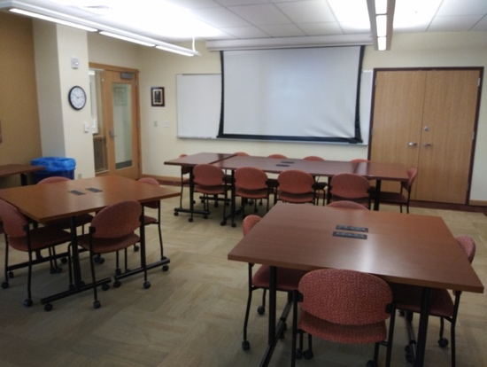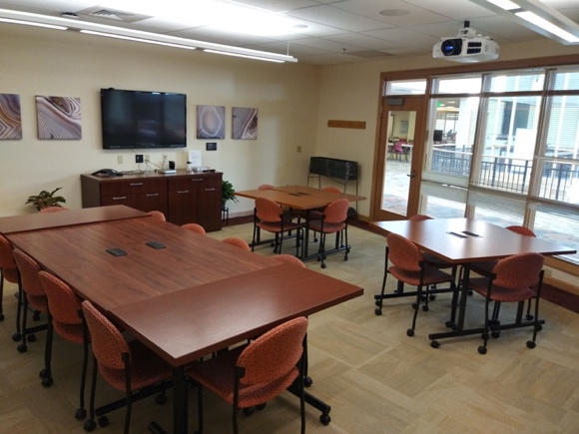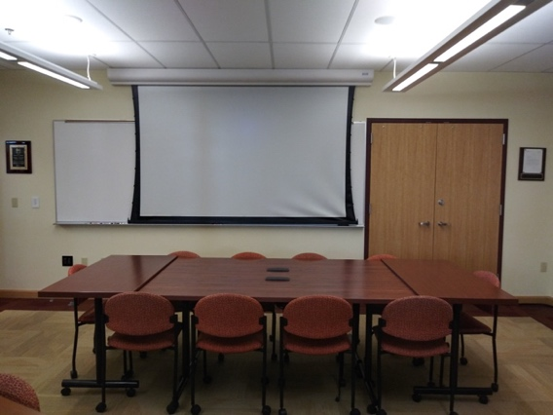

Table 1, Table 2, Table 3, Table 4
Whiteboard & Projector Screen

Cabinet TV
Door

Door

Table 5, Table 6, Table7, Table8

Multimedia Equipment
The following multimedia equipment is available in the OTL Conference Room: Mac Mini (equipped with internet access and Microsoft Office), amplified computer audio, LCD projector, drop down projection screen, and Polycom phone.

Directions for the projector are located on the top right-hand side of the cabinet.

Dongles and cables are located in the top left-hand drawer of the Cabinet.

Notify the OTL Administrative Assistant if multimedia support is needed. You are responsible for the equipment for the duration of your reservation time and any damages or missing equipment will be at the expense of the responsible party. The projector must be turned off after use.

If a major maintenance or hardware problem occurs, please notify the OTL Administrative Assistant.

Other Equipment and Services
The OTL Conference Room is equipped with a Whiteboard and dry erase markers. Dry erase markers must be used when writing on the whiteboards. Erase all boards thoroughly at the completion of your meeting and return all markers and erasers borrowed.

User Responsibility and Rules
OTL Conference Room access is provided as a convenience and service to the OTL and University. Please respect all rules and responsibilities to ensure continued availability of the facility. Failure to comply may result in suspension or cessation of future room reservations. All OTL Conference Room users must comply with the following rules and procedures:
· The OTL Conference room cannot be left unattended at any time.
· The doors to the room must be kept closed at all times due to the proximity of students and patrons using the AAC. Please keep the noise level at a minimum.
· All groups are responsible for returning the room to its default setup and cleanup of the room, including removing trash and any other meeting materials left behind.
· Whiteboard are is to be thoroughly erased upon the completion of meetings/events.
· Tables must be repositioned to their default organization.
· Do not sit on the tables or use furniture in any way except for its intended purpose.
· Smoking is prohibited in the AAC.
· Turn off all lights and the projector, if applicable, before leaving the room.
· Inform the Administrative Assistant when the meeting is concluded.
· Report any problems or concerns to the Administrative Assistant.
· Failure to return the room to its default arrangement may result in a removal of room usage privileges.

Cancellations
Cancellations of meetings must be communicated in writing to the OTL Administrative Assistant no fewer than four business days before the scheduled event. Failure to cancel events within four business days may result in a removal of room usage privileges.

Damage Fees
In all cases, the department listed on the OTL Conference Room Request Form will be responsible for all damage and cleaning costs incurred during the reservation time.

